SHREE CHANAKYA EDUCATION SOCIETY’S

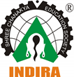
INDIRA COLLEGE OF ENGINEERING AND MANAGEMENT
Approved By AICTE New Delhi, DTE (MS) and Affiliated to Pune University (Id-No. PU/PN/Engg/282/2007)

Ref. No.: ICEM/Jan2025 Date:02 /09/2025

One Page Report on Marathi Play – “Varhad Nighalay Londonla”

Date: 30th August 2025
Venue: MPH hall
Time: 3:00 PM

Brief Report:
In view of the Ganesh Festival Celebration 2025, a special Marathi play titled “Varhad Nighalay Londonla” was organized on 30th August 2025 (Saturday) from 3:00 PM to 5:30 PM at Chanakya Campus, followed by Ganesh Aarti at 6:00 PM. The event was successfully coordinated by the Cultural Committee of Indira College of Engineering and Management.
“Varhad Nighalay Londonla” is a popular Marathi one-man play written by Dr. Lakshman Deshpande. The play is a light-hearted comedy that revolves around a rural Maharashtrian family who accepts a British woman as their daughter-in-law. It humorously captures the cultural contrasts and the family’s reactions to this unusual situation, blending traditional values with modern perspectives.
The play has been performed countless times and continues to be one of the most beloved works in Marathi theatre. Sandeep Pathak gained widespread fame for his powerful portrayal of multiple characters in the play, which became a milestone in his acting career. Other talented artists such as Nipun Dharmadhikari have also performed this play, keeping its legacy alive among theatre enthusiasts.
The event provided students and faculty with an opportunity to appreciate the depth of Marathi literature, theatre, and performance art. The humorous dialogues, expressions, and cultural elements captivated the audience and created a vibrant festive atmosphere in alignment with the Ganesh Festival celebrations.
The program concluded with a heartfelt Ganesh Aarti, symbolizing unity, devotion, and joy among students and faculty. The event was a grand success, beautifully merging cultural celebration with performing arts and reinforcing the importance of preserving Marathi theatre traditions.

Few Glimpses from the Event:

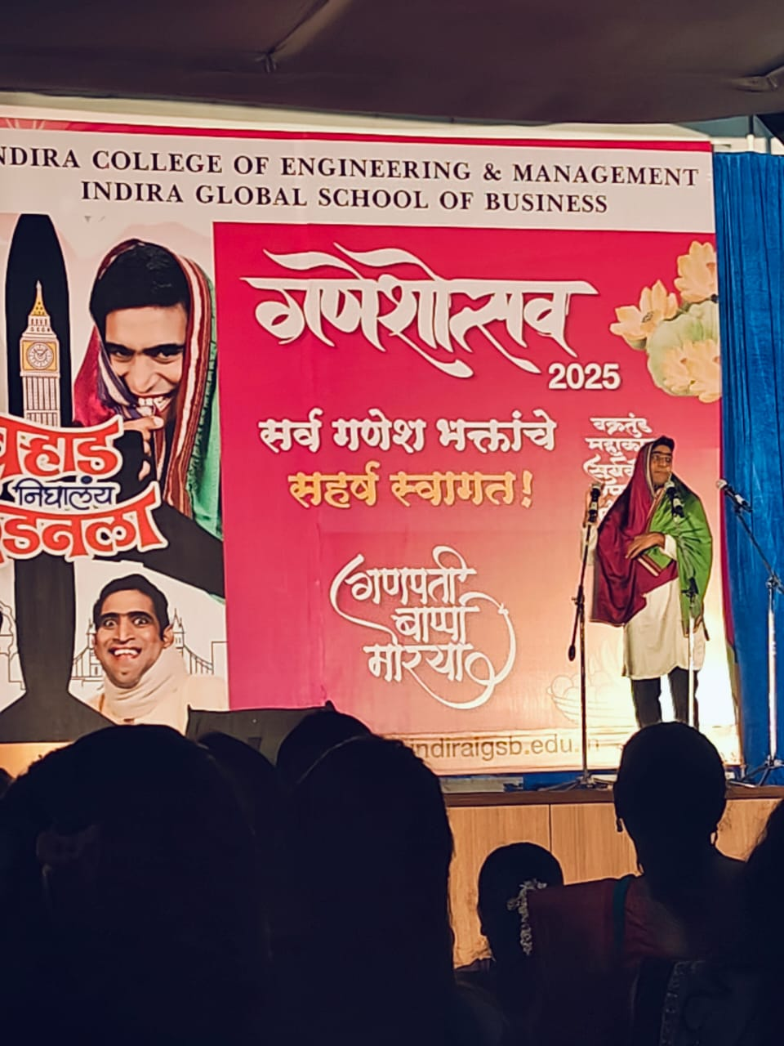

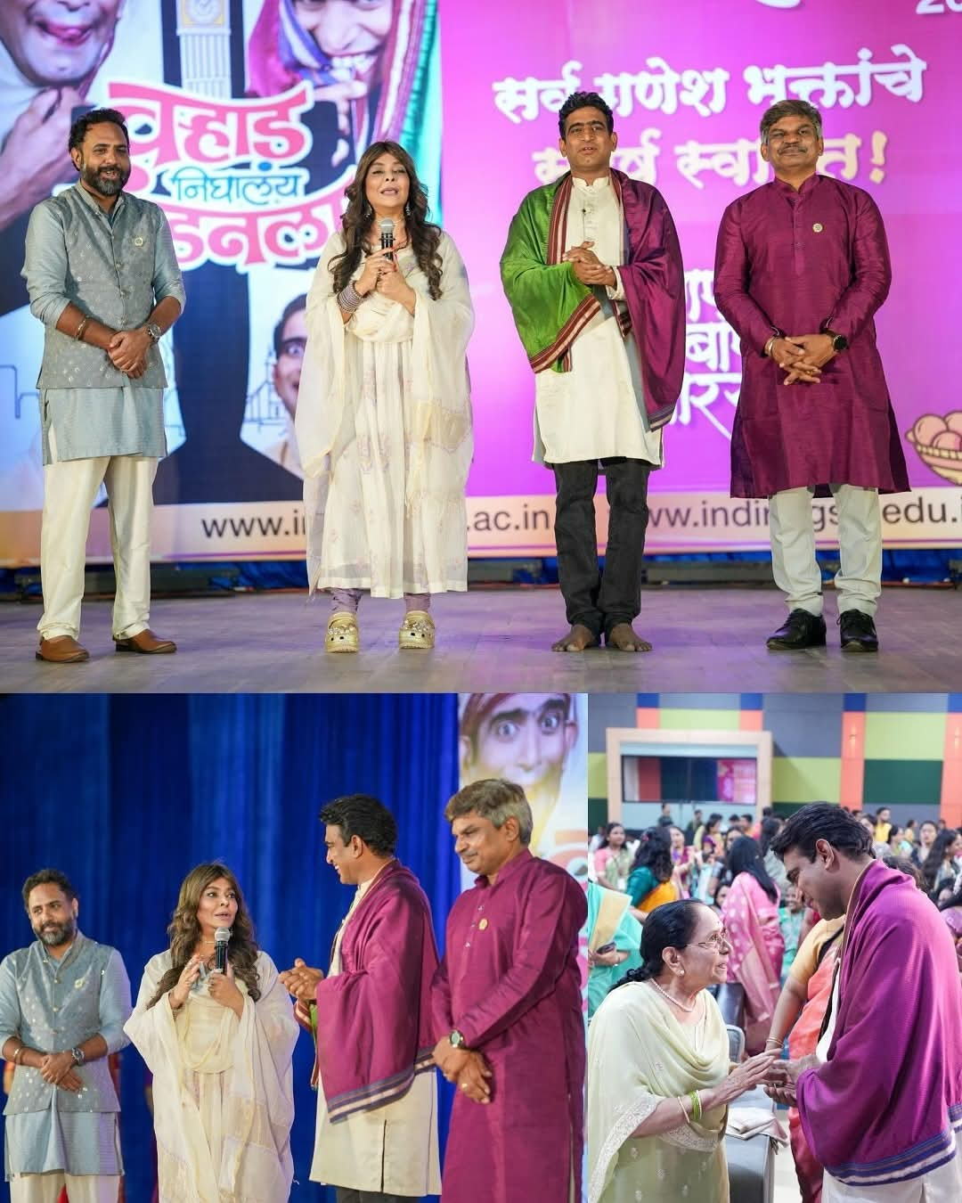

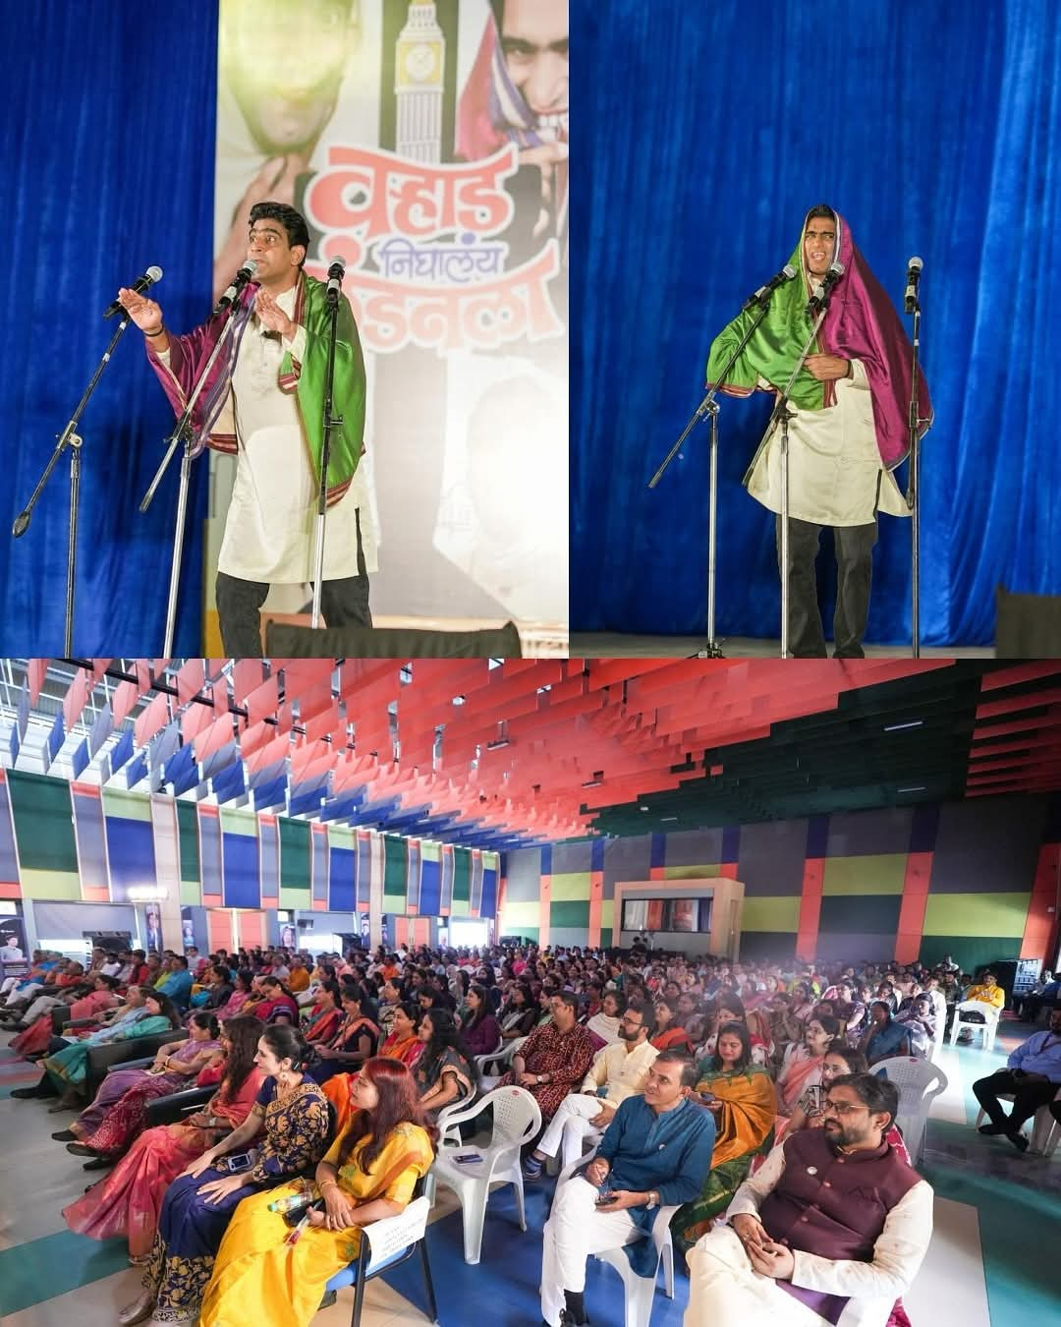

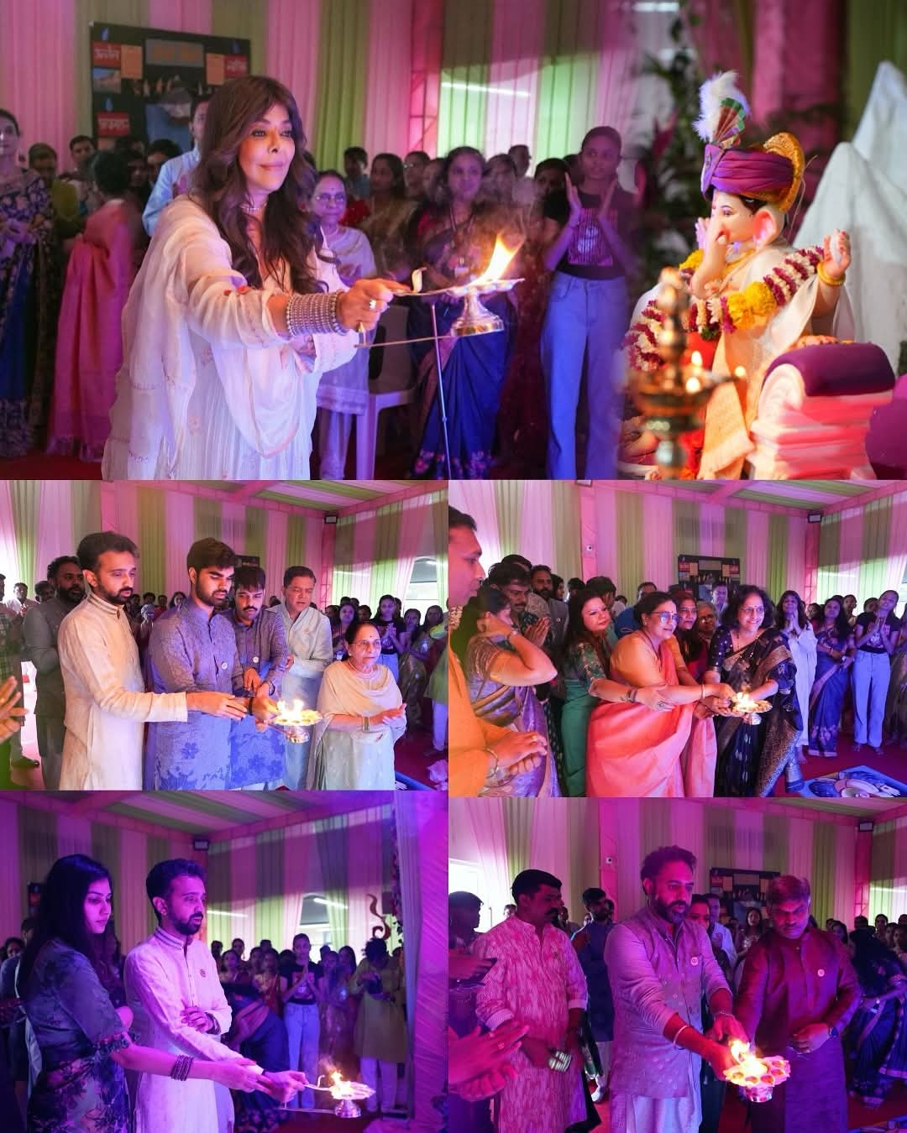

Prof.Reshma Kohad Dr. Nilesh Uke
Cultural Coordinator Principal, ICEM

